BUS 620 Case Study: Perfect Competition & Marginal Costs
Maximize Profit for a Market Garden Given Revenue, Costs, and profit of Various Crops

Introduction
A local farm operates for 36 weeks in a season, bearing a fixed cost of $20,000. The farm employs permanent and temporary labor at different wages and % time working in the field. The farmer is the only permanent employee and can only dedicate 50% of her time to working in the field.

The farm can grow three types of crops – Tomatoes, Carrots, and Mesclun. Each crop type has its specific requirements in terms of:
- revenue per bed,
- labor hours per week per bed,
- fertilizer costs, and
- diminishing returns.

The farmer aims to maximize profit based on the variable costs associated with each crop and the constraints of operating on 1.5 acres with 64 beds (16 100’x64’ beds/plot x 4 plots/acre) with limited labor resources.

Given the farm’s and each crop's constraints and revenue potential, a mix of all three crops might be ideal.

Analysis
Revenue = Price per bed x # of beds
Variable costs = Labor cost + Fertilizer cost
Total cost = Fixed cost + Variable cost
Profit = Revenue - Total cost
Marginal cost = change in total cost divided by the change in quantity (in this case, beds per season).

Assumptions & Constraints
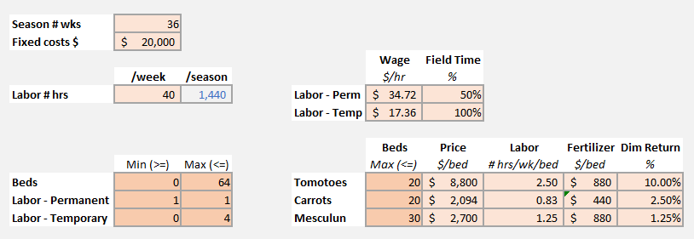

Key Tasks
- Maximize profits by identifying the optimal number of beds of each crop based on marginal costs and total profit, taking into account constraints (# of beds and # of laborers)
- Create an Output, Revenue, Costs, and Profit for the farm and each crop.
  - Calculate revenue per bed based on market prices.
  - Identify marginal costs for each crop.
  - Create a graph of the marginal cost curve.
  - Prove that price = marginal cost.
  - Calculate labor hours needed for each crop.
- Calculate the total labor costs to determine how many temporary laborers should be hired. Fractional laborers are permitted (i.e., part-time).

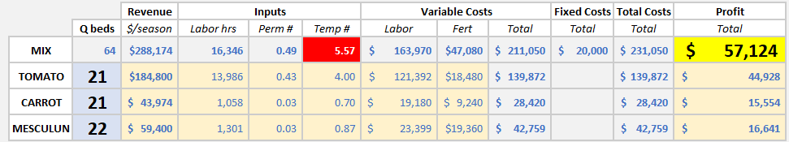

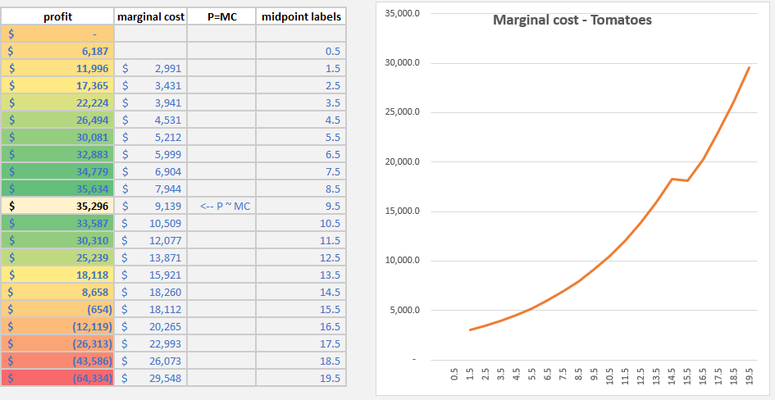

Additional Information
Three steps for working with Optimization Problems
- Model development
- Optimization
- Evaluate the solution

Class Notes
chatGPT - Excel Solver
Highest profit crop first

Here's how the given information can be organized:

**Assumptions:**
1. The farm operates for a season length of 36 weeks.
2. The farm has fixed costs of $20,000 per season.
3. The permanent labor works 40 hours per week or a total of 1,440 hours per season.
4. The price per bed indicates the revenue generated for that crop type.
5. Fertilizer costs are a direct deduction from the revenue.

**Constraints:**
1. Beds:
* Total available beds range from 0 to 64.
* Tomatoes up to 20 beds.
* Carrots up to 20 beds.
* Mesclun up to 30 beds.

2. Labor:
* Permanent labor availability is fixed at 1 individual; 50% in field.
* Temporary labor availability ranges from 0 to 4 individuals; 100% in field.

3. Costs and Labor Time:
* The maximum labor time for tomatoes is 2.50 hours per bed per week.
* The maximum labor time for carrots is 0.83 hours per bed per week.
* The maximum labor time for mesclun is 1.25 hours per bed per week.
* The maximum fertilizer cost for tomatoes is $880 per bed.
* The maximum fertilizer cost for carrots is $440 per bed.
* The maximum fertilizer cost for mesclun is $880 per bed.

**Decision Variables:**
1. Number of beds to allocate for each crop type.
2. Number of temporary laborers to hire.

**Outputs:**
1. Total revenue for the season (sum of revenue from all crop types minus direct costs like fertilizer).
2. Total labor costs for the season (wage multiplied by hours worked for both permanent and temporary labor).
3. Net profit for the season (total revenue minus total costs).

The information provided details the various inputs and parameters for decision-making on a farm. Properly managing these variables can lead to optimal profitability and efficient farm management.

To optimize profit, we need to take into consideration the revenue generated from each crop type, the costs associated with each (including labor and fertilizer), and the constraints listed.

Given the information:

**Tomatoes**:
- Revenue/bed = $8,800
- Fertilizer cost/bed = $880
- Labor hours/bed/week = 2.5 hours

**Carrots**:
- Revenue/bed = $2,094
- Fertilizer cost/bed = $440
- Labor hours/bed/week = 0.83 hours

**Mesclun**:
- Revenue/bed = $2,700
- Fertilizer cost/bed = $880
- Labor hours/bed/week = 1.25 hours

First, calculate the net revenue for each crop:

Net Revenue/bed (after fertilizer cost):
- Tomatoes: $8,800 - $880 = $7,920
- Carrots: $2,094 - $440 = $1,654
- Mesclun: $2,700 - $880 = $1,820

Next, determine labor costs:

Labor costs are dependent on the number of beds dedicated to each crop and the hours required for each.

Considering that permanent labor works 50% in the field and temporary labor 100%:

Permanent labor field hours/week = 20 hours (since 50% of 40 hours)
Temporary labor field hours/week = 40 hours (since 100% in field)

Now, we'll set up equations for the constraints:

1. Total Beds: \(B_t\) (Tomatoes) + \(B_c\) (Carrots) + \(B_m\) (Mesclun) ≤ 64
2. Labor hours needed: \(2.5B_t\) + \(0.83B_c\) + \(1.25B_m\) ≤ 20 + 40x (x is the number of temporary workers hired)

To maximize profit, based on the net revenue per bed, we should aim for more tomato beds (since they have the highest net revenue per bed). However, they also require the most labor.

Let's try a hypothetical scenario:

Say we max out tomato beds:
\(B_t\) = 20 beds.
Labor hours for tomatoes = 2.5 x 20 = 50 hours.

Remaining permanent labor hours = 20 - 50 = -30 (not feasible without temporary labor).

To cover the deficit in labor hours for tomatoes, we'd need to hire 1 temporary worker. Let's say we hire just 1 for now.

Total labor hours available now = 20 (permanent) + 40 (temporary) = 60 hours.
Hours used for tomatoes = 50.
Hours remaining = 10.

Given the remaining labor hours and bed constraints, and aiming to maximize profit, we should go for Mesclun next (higher net revenue than carrots).

If we allocate the rest of the available hours for Mesclun, we can accommodate:
10/1.25 = 8 beds of Mesclun.

So in this scenario:
Tomatoes = 20 beds
Carrots = 0 beds
Mesclun = 8 beds
Total beds = 28 (well within the 64 bed constraint)

However, this is just one scenario. There could be multiple combinations to explore, and a mathematical optimization model (like Linear Programming) would be best suited to find the optimal combination of crop beds and laborers to maximize profit.

